## Reports/ Rx Reports/ Price Below Cost Report

Request:

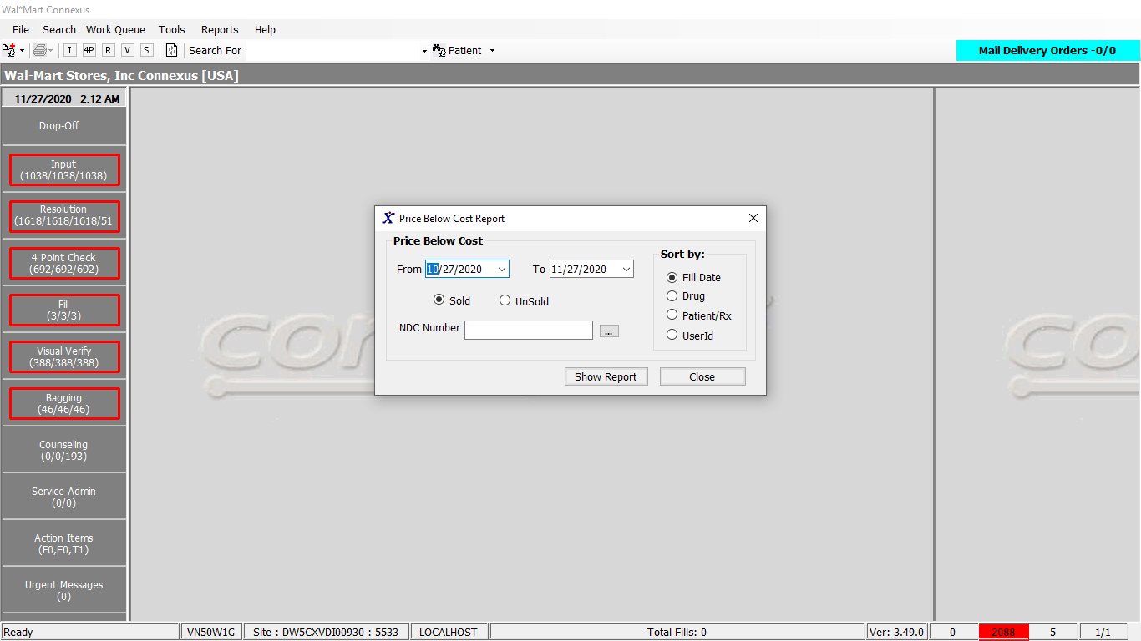

Response:

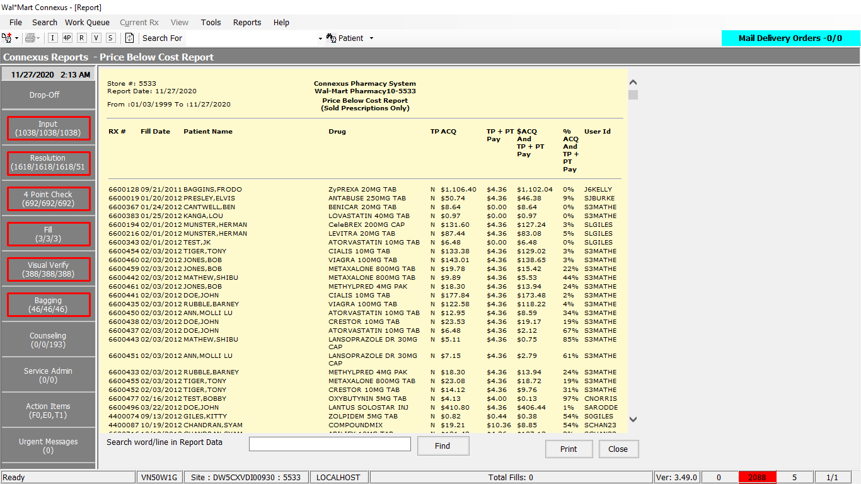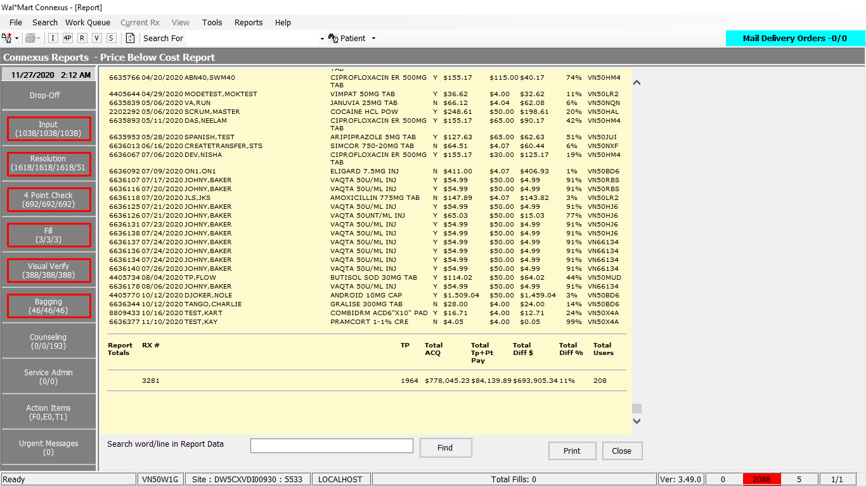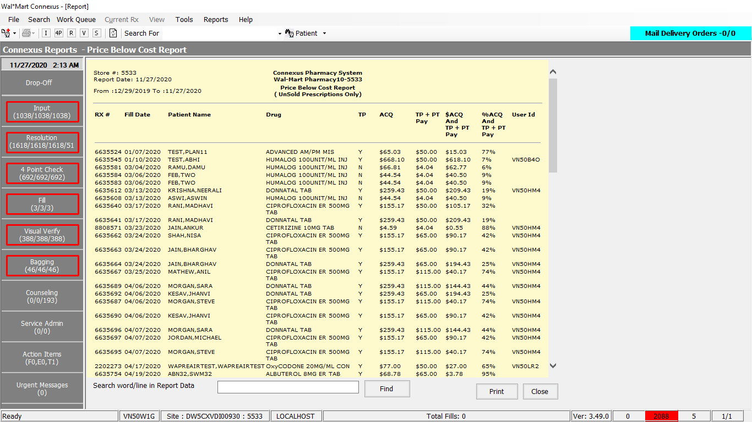

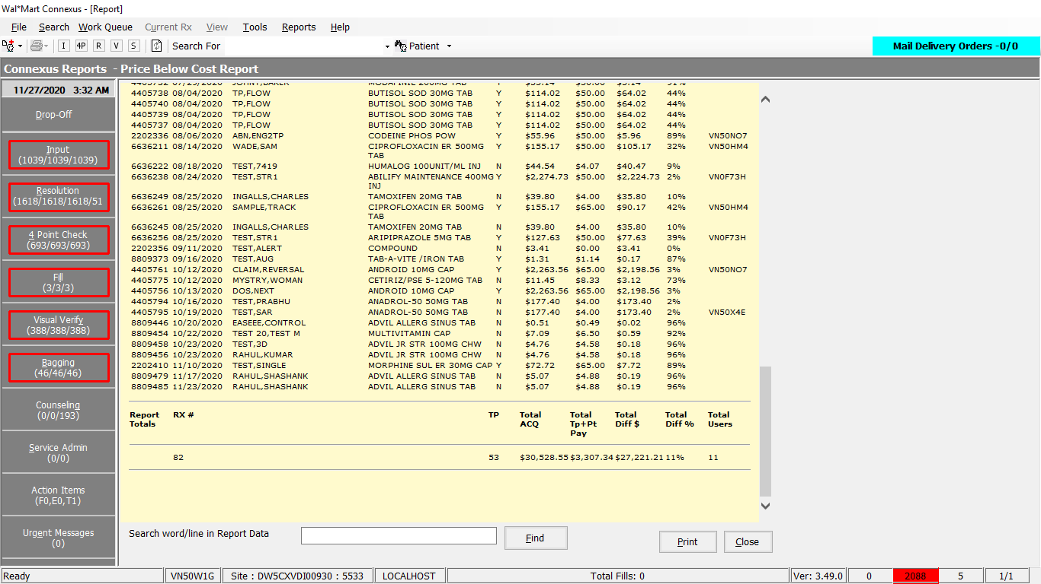

Queries:

1. Friend Const GetPriceBelowCostReportDataSelect1 As String = "SELECT rx_nbr, rf.rx_fill_id, TRIM(NVL(pat.last_name,'')) || ',' || TRIM(NVL(pat.first_name,'')) || ' ' || trim(nvl(pat.middle_name,'')) pat_name, rf.fill_date, CASE WHEN rx.compound_ind ='Y' then c.compound_name WHEN rx.compound_ind !='Y' THEN pp.short_name END drug_name, SUM(rfi2.actual_cost_amt) cost_amt, rf.third_party_ind, pos_sale_amt, rf.rph_of_rec_userid userid, rx.rx_id FROM rx, patient pat, rx_fill rf, rx_fill_item rfi, rx_fill_item rfi2, pharmacy_offering:pharmacy_product pp, pharmacy_offering:pharmacy_item pi, OUTER (rx_compound rxc, compound c) WHERE rx.rx_id = rf.rx_id AND rx.rx_id = rxc.rx_id AND rxc.compound_id = c.compound_id AND rx.patient_id = pat.patient_id AND rf.rx_fill_id = rfi.rx_fill_id AND rfi.item_mds_fam_id = pi.mds_fam_id AND pi.product_mds_fam_id = pp.product_mds_fam_id AND rfi.item_seq_nbr = 1 AND rf.rx_fill_id = rfi2.rx_fill_id AND rf.status_code = 20401 AND rf.pos_ts IS NOT NULL AND rf.fill_date >= ? AND rf.fill_date <= ? "

2. Friend Const GetPriceBelowCostReportDataSelect2 As String = "SELECT rx_nbr, rf.rx_fill_id, TRIM(NVL(pat.last_name,'')) || ',' || TRIM(NVL(pat.first_name,'')) || ' ' || trim(nvl(pat.middle_name,'')) pat_name, rf.fill_date, CASE WHEN rx.compound_ind ='Y' THEN c.compound_name WHEN rx.compound_ind !='Y' THEN pp.short_name END drug_name, SUM(rfi2.actual_cost_amt) cost_amt, rf.third_party_ind, pos_due_amt, rf.rph_of_rec_userid userid, rx.rx_id FROM rx, patient pat, rx_fill rf, rx_fill_item rfi, rx_fill_item rfi2, pharmacy_offering:pharmacy_product pp, pharmacy_offering:pharmacy_item pi, OUTER (rx_compound rxc, compound c) WHERE rx.rx_id = rf.rx_id AND rx.rx_id = rxc.rx_id AND rxc.compound_id = c.compound_id AND rx.patient_id = pat.patient_id AND rf.rx_fill_id = rfi.rx_fill_id AND rfi.item_mds_fam_id = pi.mds_fam_id AND pi.product_mds_fam_id = pp.product_mds_fam_id AND rfi.item_seq_nbr = 1 AND rf.rx_fill_id = rfi2.rx_fill_id AND rf.status_code = 20401 AND rf.pos_ts IS NULL AND rf.fill_date >= ? AND rf.fill_date <= ? "

Dal:

Public Function GetPriceBelowCostReportData(ByVal siteId As Integer, ByVal fromDate As DateTime,

ByVal toDate As DateTime, ByVal sortIndex As String,

ByVal productId As Integer, ByVal orderBy As Integer) _

As List(Of GetPriceBelowCostReportDataInfoBE) Implements IReportDAL.GetPriceBelowCostReportData

Using (New Tracer(ConnexusCommonConstants.ConnexusTracer))

Dim sqlString As New StringBuilder

Dim fromDate1 As Date

Dim toDate1 As Date

Dim getPriceBelowCostReportBEList As New List(Of GetPriceBelowCostReportDataInfoBE)

Dim paramList As New List(Of DbParameter)

'Doubt

Dim strOrderBy As String

strOrderBy = "rf.fill_date"

If orderBy = 1 Then

strOrderBy = "rf.fill_date"

ElseIf orderBy = 2 Then

strOrderBy = "drug_name"

ElseIf orderBy = 3 Then

strOrderBy = "pat_name"

ElseIf orderBy = 4 Then

'D1758:Passing userid field for sorting the records

strOrderBy = "userid"

End If

fromDate1 = CDate(fromDate.ToShortDateString())

toDate1 = CDate(toDate.ToShortDateString())

If sortIndex.Equals("Y") Then

'SQL Query for POS

sqlString.Append(ReportQueries.GetPriceBelowCostReportDataSelect1)

paramList.Add(ParameterHelper.BuildParameter("fillDate", DbType.Date,

fromDate1))

paramList.Add(ParameterHelper.BuildParameter("fillDate", DbType.Date,

toDate1))

If productId > 0 Then

sqlString.Append(" AND pp.product_mds_fam_id = ? ")

paramList.Add(ParameterHelper.BuildParameter("productMDSFamId", DbType.Int32,

productId))

End If

sqlString.Append(" GROUP BY 1,2,3,4,5,7,8,9,10 ")

sqlString.Append(" HAVING sum(rfi2.actual_cost_amt) > pos_sale_amt ORDER BY ")

sqlString.Append(strOrderBy)

Else

'SQL Query for Connexus

sqlString.Append(ReportQueries.GetPriceBelowCostReportDataSelect2)

paramList.Add(ParameterHelper.BuildParameter("fillDate", DbType.Date,

fromDate1))

paramList.Add(ParameterHelper.BuildParameter("fillDate", DbType.Date,

toDate1))

If productId > 0 Then

sqlString.Append(" AND pp.product_mds_fam_id = ? ")

paramList.Add(ParameterHelper.BuildParameter("productMDSFamId", DbType.Int32,

productId))

End If

sqlString.Append(" GROUP BY 1,2,3,4,5,7,8,9,10")

sqlString.Append(" HAVING sum(rfi2.actual_cost_amt) > pos_due_amt ORDER BY ")

sqlString.Append(strOrderBy)

End If

Dim dataReader As IDataReader = ExecuteReader(DatabaseEnum.rx21c, siteId,

sqlString.ToString, paramList)

Dim getPriceBelowCostReportBE As GetPriceBelowCostReportDataInfoBE

While dataReader.Read

getPriceBelowCostReportBE = New GetPriceBelowCostReportDataInfoBE

If Not dataReader.IsDBNull(dataReader.GetOrdinal("cost_amt")) Then

getPriceBelowCostReportBE.CostAmt = CDec(dataReader("cost_amt"))

End If

If Not dataReader.IsDBNull(dataReader.GetOrdinal("drug_name")) Then

getPriceBelowCostReportBE.DrugName = CStr(dataReader("drug_name")).Trim

End If

If Not dataReader.IsDBNull(dataReader.GetOrdinal("fill_date")) Then

getPriceBelowCostReportBE.FillDate = CDate(dataReader("fill_date"))

End If

If Not dataReader.IsDBNull(dataReader.GetOrdinal("pat_name")) Then

getPriceBelowCostReportBE.PatName = CStr(dataReader("pat_name")).Trim

End If

If sortIndex.Equals("Y") Then

If Not dataReader.IsDBNull(dataReader.GetOrdinal("pos_sale_amt")) Then

getPriceBelowCostReportBE.PosSaleAmt = CDec(dataReader("pos_sale_amt"))

End If

Else

If Not dataReader.IsDBNull(dataReader.GetOrdinal("pos_due_amt")) Then

getPriceBelowCostReportBE.PosDueAmt = CDec(dataReader("pos_due_amt"))

End If

End If

If Not dataReader.IsDBNull(dataReader.GetOrdinal("rx_fill_id")) Then

getPriceBelowCostReportBE.RxFillId = CInt(dataReader("rx_fill_id"))

End If

If Not dataReader.IsDBNull(dataReader.GetOrdinal("rx_id")) Then

getPriceBelowCostReportBE.RxId = CInt(dataReader("rx_id"))

End If

If Not dataReader.IsDBNull(dataReader.GetOrdinal("rx_nbr")) Then

getPriceBelowCostReportBE.RxNbr = CInt(dataReader("rx_nbr"))

End If

If Not dataReader.IsDBNull(dataReader.GetOrdinal("third_party_ind")) Then

getPriceBelowCostReportBE.ThirdPartyInd = CStr(dataReader("third_party_ind")).Trim

End If

If Not dataReader.IsDBNull(dataReader.GetOrdinal("userid")) Then

getPriceBelowCostReportBE.UserId = CStr(dataReader("userid")).Trim

End If

getPriceBelowCostReportBEList.Add(getPriceBelowCostReportBE)

End While

If getPriceBelowCostReportBEList.Count > 0 Then

Return getPriceBelowCostReportBEList

Else

Return Nothing

End If

End Using

End Function